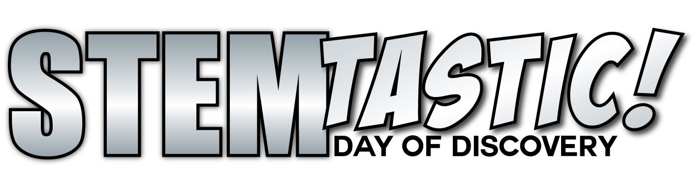­­­

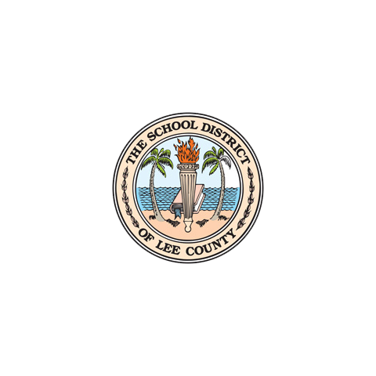

**Save the Date**

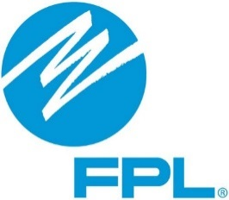­­­

Register your group: https://goo.gl/forms/aQQ9UyHr5TOHgEy72

**@ Lee Co Public Education Center**

**STEMtastic invites all Lee County Public Schools, Organizations, & Business Partners to showcase their best STEM activities by organizing interactive stations where students and parents are encouraged to participate in hands-on STEM activities.**

**February 9, 2019**

**10 a.m. – 3 p.m.­**